Wenonah High School Grand Alumni Association Doing it Again!

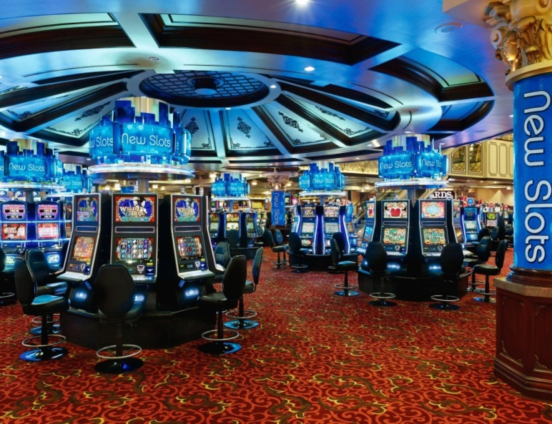

COME TAKE A RIDE WITH US TO

WIND CREEK CASINO – WETUMPKA AL
ON OUR PARTY BUS
IF YOU MISSED THE LAST ONE, DON’T MISS THIS ONE!

WHEN: SATURDAY, JUNE 6, 2015
DEPARTURE TIME: 7:30 A.M.
WHERE: BELEVIEW PLAZE, FAIRFIELD, AL

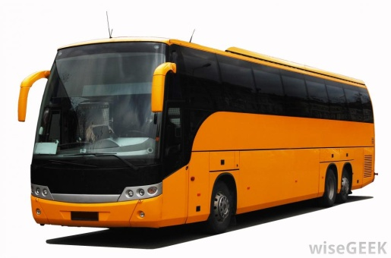

$30.00 EACH PERSON
FOR INFORMATION ON PURCHASING TICKETS CONTACT
ROSALIND RUDOLPH YOUNG, 205-602-1908
OR
JAMES E CARDEN, 205-424-09565

ITINERARY
DEPART @ 7:30 A. M. FROM BELLEVIEW PLAZA, JUNE 6, 2015
ARRIVE @ WIND CREEK CASINO - WETUMPKA @ 9:30 A. M.
RECEIVE ONE $15.00 FOOD CREDIT
RECEIVE ONE “PLAY AND GET” BONUS (PER PLAYER, PER BUS)
DEPART FROM WIND CREEK - WETUMPKA @ 2:30 P. M.
ARRIVE IN BIRMINGHAM @ 4:30 P.M.

