Wenonah High School FCCLA
Is Spreading the Word!
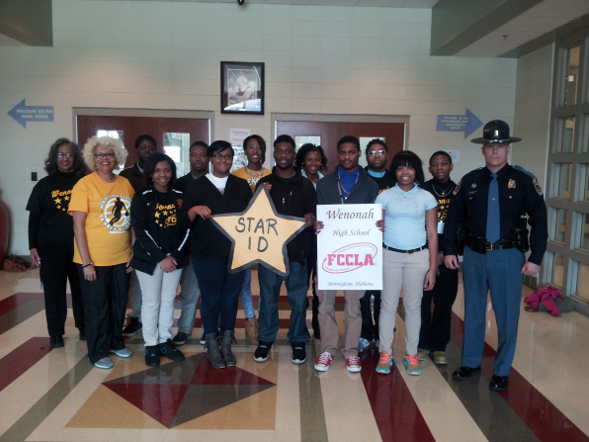
(Pictured left to right: Denise Y. Rucker, FCCLA Adviser, Regina Hope, Principal, Jalen Elms, Antionette Pugh, Justin Calhoun, Bridgette Caver, Alexis Cowart, Corderion Hamilton, Amber Carter, Shea Glaster, William Smith, Diamond Moses, J’Ques Everett and Trooper Chuck Daniels)
Do You Have Your STAR ID?
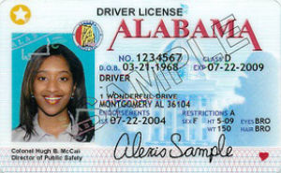
http://www.google.com/search?q=alabama+star+id&biw=1245&bih=903&source=lnms&tbm=isch&sa=X&ei=PhLlVOq1J8ipgwSMooKYBA&sqi=2&ved=0CAgQ_AUoAw&dpr=1#imgdii=_&imgrc=CY8m_2GEmQ_WM%253A%3Bw7drITalZD_7DM%3Bhttp%253A%252F%252Fbloximages.newyork1.vip.townnews.com%252Fsoutheastsun.com%252Fcontent%252Ftncms%252Fassets%252Fv3%252Feditorial%252Ff%252Fe8%252Ffe84052e-7c9c-11e3-96c2-001a4bcf6878%252F52d46047e1430.preview-300.jpg%3Bhttp%253A%252F%252Fm.southeastsun.com%252Fmobile%252Fnews%252Farticle_3a0725fa-7c9c-11e3-b125-001a4bcf6878.html%3B300%3B185
What is a STAR ID?
“Secure, Trusted, And Reliable,” STAR ID is part of a nationwide effort to improve the integrity and security of state-issued driver licenses and identification cards, which, in turn, will help fight terrorism and reduce fraud. REAL ID compliant licenses and ID cards have a star in the upper right corner.
Without one you will not be able to board a commercial airplane (unless you have a valid passport) and you will not be able to enter a regulated federal building (not post offices; a federal building that has armed security at doors; Social Security building, federal court house)
Why was STAR ID developed?
In response to acts of terrorism committed against the United States, and in an effort to ensure the safety of citizens, Congress passed the REAL-ID Act of 2005, modifying federal laws pertaining to security, authentication and issuance procedure standards for state driver licenses and identification cards. In order to comply with the requirements of this federal legislation, the Alabama Department of Public Safety has developed the STAR ID program. This will go in effect in 2016.
For more information go to the following websites:
http://dps.alabama.gov/Home/wfContent.aspx?ID=80&PLH1=plhDriverLicense-StarIDFAQ
http://www.montgomeryadvertiser.com/story/news/local/2014/12/24/enforcement-star-set-begin/20870977/
Mrs. Rucker’s FCCLA chapter started spreading the word earlier this year by making presentations and handing out informative brochures at Open House and the Wenonah High School Grand Alumni banquet and recently to the Explorers of the Birmingham Fire Department. In their quest for validity 12th grader Bridgette Caver and 11th grader Corderion Hamilton contacted the governor’s office who put them in contact with Trooper Chuck Daniels. Trooper Daniels has been instrumental in researching any questions the students have come across that they did not know the answers to. Bridgette and Corderion along with their fellow members of their Family, Career and Community Leaders of America (FCCLA) chapter have made an infomercial that they are sending across the state to bring awareness to the changes that are about to happen.
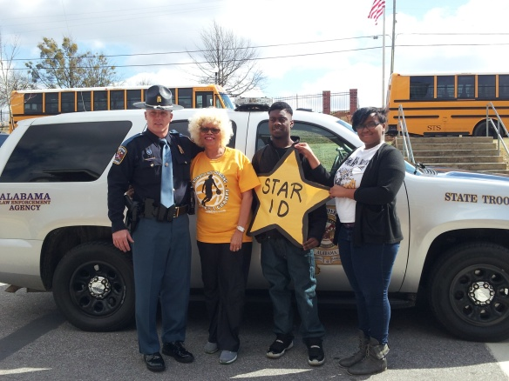
(Pictured left to right: Trooper Chuck Daniels, Regina Hope, Principal, Corderion Hamilton and Bridgette Caver)

